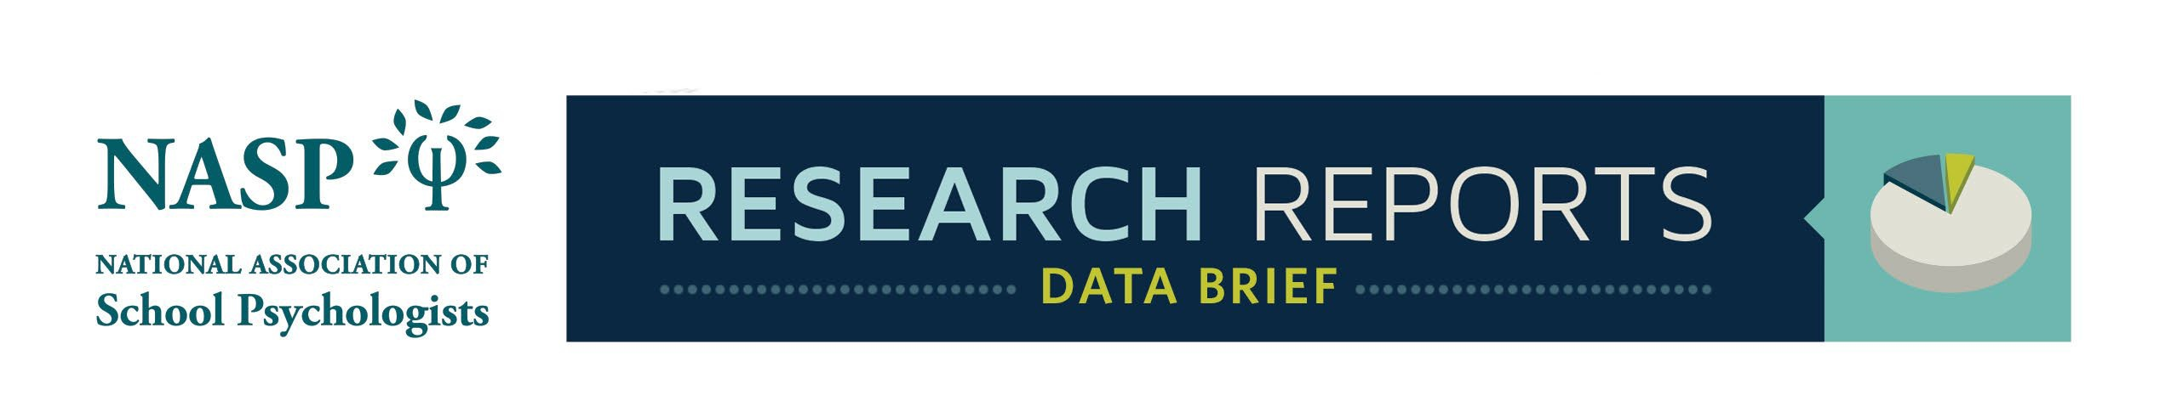

Volume 9, Number 2, April 2025
2023–2024 Ratio of Students to Full-Time Equivalent School
Psychologists in U.S. Public Elementary and Secondary Schools
Nicholas W. Affrunti Shereen Naser, PhD, Editor
National Association of School Psychologists Cleveland State University
Nicholas W. Affrunti, PhD, Coeditor
National Association of School Psychologists
ABSTRACT
The current brief summarizes the 2023–2024 school year’s student to school psychologist ratio for
every United States territory, using the National Center for Education Statistics counts of school
psychologists. Besides this, data are presented on the percentage change in student to school
psychologist ratio from the 2022–2023 school year to the 2023–2024 school year (i.e., the currently
released data). When territory ratios for the 2023–2024 school year were examined by region, the
data displayed significant differences. No associations were found between the student to school
psychologist ratio and territory population, the number of graduate programs in school psychology in
that territory, or the average school psychologist’s salary. This information is vital for tracking
workforce shortages, as well as the effects of advocacy efforts throughout the country.
Keywords: School psychology, staffing, workforce, shortages, public education
Correspondence regarding this article should be addressed to Nicholas W. Affrunti, National Association of School
Psychologists, 4340 East West Highway, Suite 402, Bethesda, MD 20814; 301-657-1646; naffrunti@naspweb.org.
The National Center for Education Statistics (NCES), part of the U.S. Department of Education,
annually releases itsCommon Core of Data(CCD), which includes a comprehensive database on
public elementary and secondary education across the United States (NCES, 2025). Starting with the
2019–2020 school year release and continuing with the current release of the 2023–2024 school
year, this dataset includes counts of full-time equivalent (FTE) school psychologists. Because school
psychologist counts are completed by territory, ratios of students to school psychologists for each
territory are easily calculated. These data represent the most comprehensive attempt at determining
ratios for each territory, as well as for the United States overall. For ease of reading, all states and
territories will be referred to as territories in this brief.
Tracking the ratio of students to school psychologists in each territory and for the nation is vital to
understanding whether the school psychology workforce is growing to meet the increased demand for
school psychological services. Additionally, it allows individuals engaging in advocacy around
workforce shortages to know where efforts are improving ratios and where more resources are still
needed. Addressing workforce shortages, indicated by student to school psychologist ratios, is also a
strategic goal of the National Association of School Psychologists (NASP).
This Data Brief reviews both the current year’s data and trends from the previous year, to examine
the following questions:
NASP Research Reports 1
©2025 National Association of School Psychologists │ www.nasponline.org │ 301-657-0270 │ 866-331-6277

Data Brief: 2023–2024 Ratio of Students to FTE School Psychologists in U.S. Public Schools
• What is each territory’s 2023–2024 school year ratio of students to school psychologists?
• How many territories meet NASP’s recommended ratio of 500 students per school psychologist
(NASP, 2020)?
• What is the percentage change in each territory’s ratio from the previous year?
• Are there differences in the student to school psychologist ratio by region, or are there any
associations with territory population, number of school psychology graduate education programs,
or the average salary of school psychologists?
Figure 1 presents each U.S. territory’s student to school psychologist ratios for the 2023–2024 school
year. Guam and American Samoa did not report data for the 2023–2024 school year. The vertical
green line denotes a ratio of 500 students to 1 school psychologist, which is NASP’s recommended
ratio (NASP, 2020). The data show that only three territories currently meet or fall below the
recommended ratio: Connecticut, Puerto Rico, and Maine. Additionally, the data show that the
national ratio of students per school psychologist is 1,065. Although this number is well above the 500
to 1 recommendation, it does represent a 5.5% decrease from the 2022–2023 school year (Affrunti,
2024). This means that the national ratio improved from 2022–2023 to 2023–2024 (i.e., fewer children
per school psychologist).
Figure 2 displays the change in student to school psychologist ratio, as a percentage, from 2022–
2023 to 2023–2024. As the data show, approximately 70% (39) of the territories decreased their ratio
(i.e., fewer students per school psychologist), with Maine, Alabama, New Mexico, North Dakota, and
Rhode Island all showing greater than 15% decreases in their ratio. Data show that the U.S. Virgin
Islands, Utah, Hawaii, and Mississippi increased (i.e., more students per school psychologist) their
ratios by greater than 10%.
Figure 3 displays the mean and standard deviation for the students per school psychologist ratio for
each region for the 2023–2024 school year. A territory’s affiliation was determined based on NASP’s
regional affiliations. Table 1 provides the regional affiliation for all territories. Table 2 provides the
descriptive statistics for all regions. A Kruskal-Wallis test was conducted to determine whether any
significant differences existed between regions. Importantly, Alabama, Mississippi, and New Mexico
were not included in the following tests over concerns their counts were outliers.

= .58 (Tomczak & Tomczak, 2014). Post hoc Dwass-Steel-Critchlow-Flinger pairwise comparisons
showed that the Northeast region had a significantly lower ratio than the Central, W = -5.15, p= .002,
Western, W= 4.61, p= .006 and Southeast, W= 5.86, p< .001, regions. Additionally, the Western
region had a significantly lower ratio than the Southeast, W = -4.18, p= .017, and the Central region
had a significantly lower ratio than the Southeast, W = 3.65, p= .049. No other regional differences
were observed.
NASP Research Reports 2
©2025 National Association of School Psychologists │ www.nasponline.org │ 301-657-0270 │ 866-331-6277

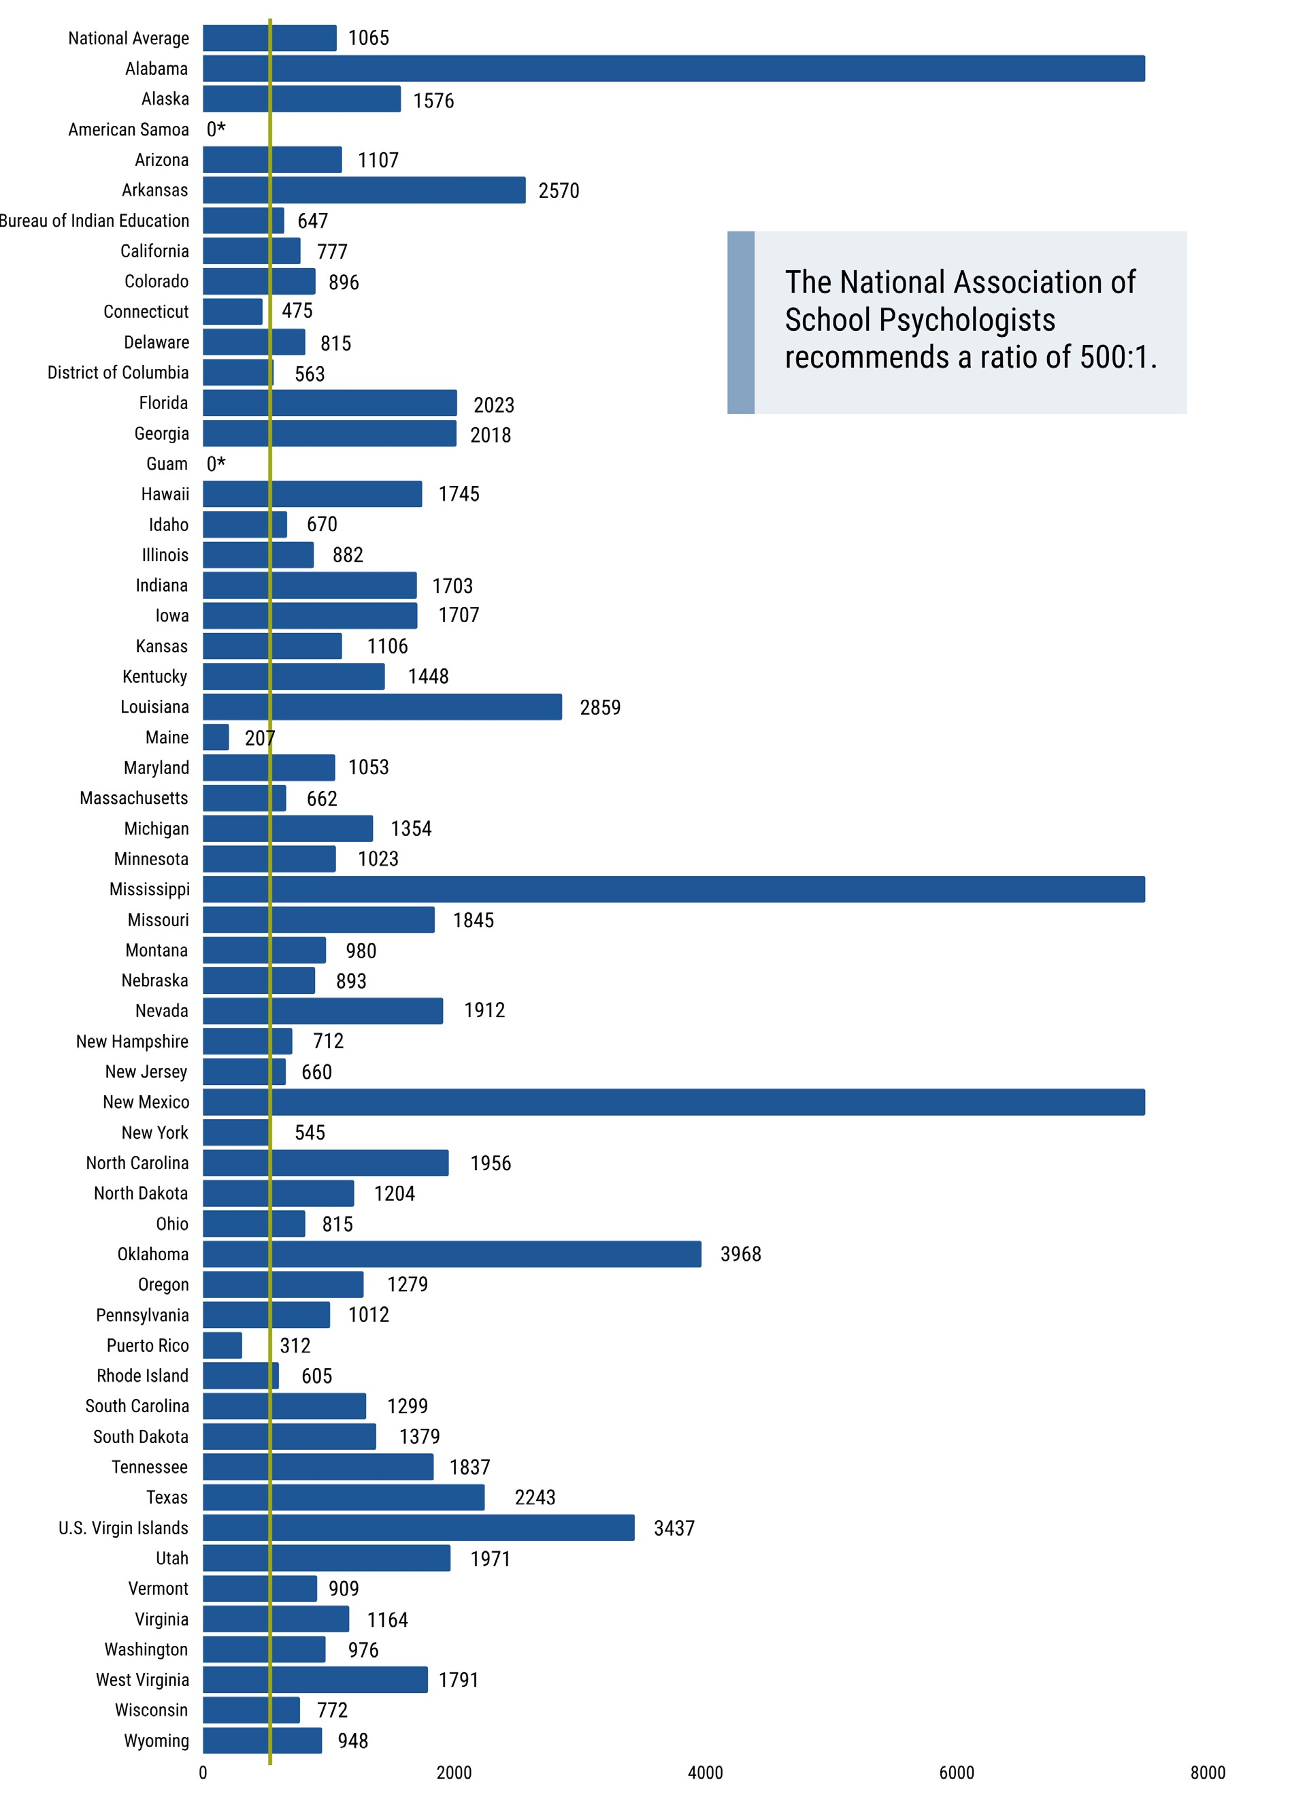

Data Brief: 2023–2024 Ratio of Students to FTE School Psychologists in U.S. Public Schools
Figure 1. Student to School Psychologist Ratio by Territory for 2023–2024
NASP Research Reports 3
©2025 National Association of School Psychologists │ www.nasponline.org │ 301-657-0270 │ 866-331-6277

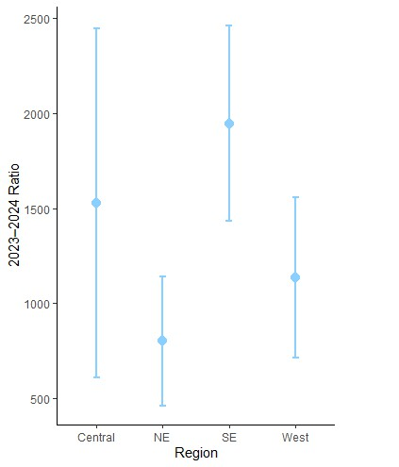
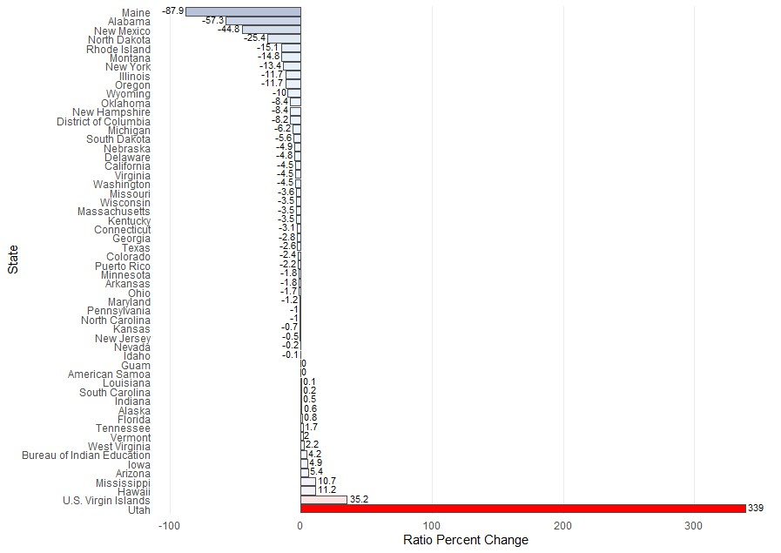

Data Brief: 2023–2024 Ratio of Students to FTE School Psychologists in U.S. Public Schools
Figure 2. Percentage Change in Student to School Psychologist Ratio From 2022–2023 to
2023–2024
Figure 3. Differences in Student to School Psychologist Ratios by Region
NASP Research Reports 4
©2025 National Association of School Psychologists │ www.nasponline.org │ 301-657-0270 │ 866-331-6277

Data Brief: 2023–2024 Ratio of Students to FTE School Psychologists in U.S. Public Schools
Table 1. Region Affiliations
Northeast (NE) Southeast (SE) Central West
Connecticut Alabama Iowa Alaska
District of Columbia Arkansas Illinois Arizona
Delaware Florida Indiana California
Massachusetts Georgia Kansas Colorado
Maine Kentucky Michigan Hawaii
Maryland Louisiana Minnesota Idaho
New Hampshire Mississippi Missouri Montana
New Jersey North Carolina North Dakota New Mexico
New York South Carolina Nebraska Nevada
Pennsylvania Tennessee Ohio Oregon
Puerto Rico Texas Oklahoma Utah
Rhode Island Virginia South Dakota Washington
Vermont West Virginia Wisconsin Wyoming
Note. Bureau of Indian Education, Guam, American Samoa, and U.S. Virgin Islands are not included in the table
above because they are not included in NASP’s regional affiliations.
Table 2. Region Means, Standard Deviations, and Standard Errors
Region N Mean SD SE
Central 13 1437 840 233
Northeast (NE) 13 656 251 69.5
Southeast (SE) 11 1928 513 155
West 12 1236 453 131
Note. SE and West regions include only 11 and 12 states, respectively, in descriptive calculations because Alabama,
Mississippi, and New Mexico were not included over concerns that they were outliers.
Figure 4 plots the 2023–2024 ratio against the number of graduate programs in each territory. As
shown by the data, there is no significant association between the number of graduate programs in a
territory and its ratio of students to school psychologists r(49) =−.08, p= .59.
NASP Research Reports 5
©2025 National Association of School Psychologists │ www.nasponline.org │ 301-657-0270 │ 866-331-6277

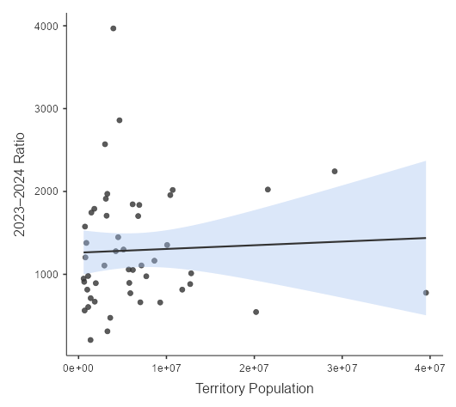
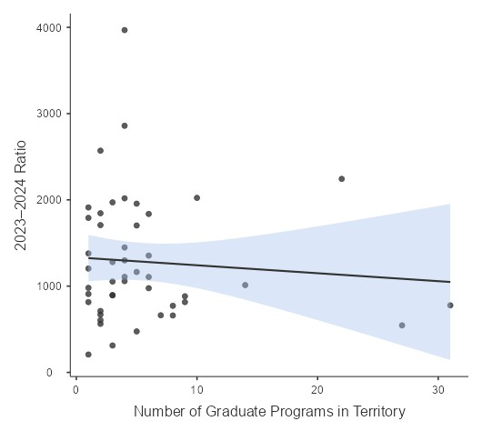

Data Brief: 2023–2024 Ratio of Students to FTE School Psychologists in U.S. Public Schools
Figure 4. Scatterplot of 2023–2024 Student to School Psychologist Ratio by Number of
Graduate Programs in Territory
Figure 5 plots the 2023–2024 student to school psychologist ratio against the population of a territory.
As shown by the data, there is no significant association between the population of a territory and its
ratio of students to school psychologistsr(49) = .05, p= .75.
Figure 5. Scatterplot of 2023–2024 Student to School Psychologist Ratio by Territory Population
NASP Research Reports 6
©2025 National Association of School Psychologists │ www.nasponline.org │ 301-657-0270 │ 866-331-6277

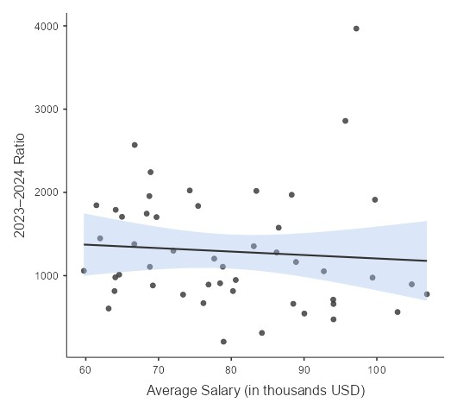

Data Brief: 2023–2024 Ratio of Students to FTE School Psychologists in U.S. Public Schools
Figure 6 plots the 2023–2024 student to school psychologist ratio against the average salary for the
territory in 2022. As shown by the data, there is no significant association between the average salary
of a school psychologist in a territory and its ratio of students to school psychologists r(49) =−.08, p=
.60.
Figure 6. Scatterplot of 2023–2024 Student to School Psychologist Ratio by Average Salary
HIGHLIGHTS
• The national ratio of students per school psychologist was 1,065 to 1 in 2023–2024. This was a
5.5% decrease from a ratio of 1,127 to 1 in 2021–2022.
• More than two thirds of U.S. territories decreased their ratio of students to school psychologists
(i.e., had fewer students per school psychologist) from 2022–2023 to 2023–2024.
• The largest ratio decreases by percentage change (i.e., fewer students per school psychologist)
were observed in Maine, Alabama, New Mexico, North Dakota, and Rhode Island. All had greater
than 15% decreases from 2022–2023 to 2023–2024.
• The largest ratio increases by percentage change (i.e., increased students per school
psychologist) were observed in the U.S. Virgin Islands, Utah, Hawaii, and Mississippi, which each
had a greater than 10% increase from 2022–2023 to 2023–2024.
• The Northeast region had significantly smaller 2023–2024 student to school psychologist ratios
(i.e., fewer students per school psychologist) than all other regions. The Western and Central
regions had a significantly smaller 2023–2024 student to school psychologist ratio than the
Southeast region. No other regional differences were observed.
• No associations were observed between 2023–2024 student to school psychologist ratio and
territory population, number of school psychology graduate education programs, or average
school psychologist salary.
NASP Research Reports 7
©2025 National Association of School Psychologists │ www.nasponline.org │ 301-657-0270 │ 866-331-6277

Data Brief: 2023–2024 Ratio of Students to FTE School Psychologists in U.S. Public Schools
TECHNICAL INFORMATION
All data for this brief are publicly available as part of the NCES’s Common Core of Data(NCES,
2025), the Bureau of Labor StatisticsOccupational Employment and Wages (Bureau of Labor
Statistics, 2022), or theNational School Psychology Program Database Survey (Gadke et al., 2025).
Ratios were calculated by dividing the number of students by the number of FTE school psychologists
within a territory. To be as inclusive as possible to territories, and not eliminate valid counts, outlier
values were defined as occurring if they were greater than 3 standard deviations from the mean.
Outliers were removed for analyses between territories and regions, but they were kept for
percentage change analyses (i.e., analyses within territories). This affected three territories: Alabama,
Mississippi, and New Mexico.
Other limitations to these data exist. First, some territories did not provide data for specific years used
in the current analyses (e.g., Guam and American Samoa did not report counts of school
psychologists). Second, some territory counts of school psychologists may be inaccurate; however, it
is difficult to ascertain where such errors exist without a separate, comparable data source. Lastly,
counts of school psychologists may not match internally collected data within territories. Territory
representatives can work with their respective CCD coordinators to help rectify any inaccuracies.
Despite these limitations, the level of detail provided with these data would be difficult to obtain if they
were not part of the CCD. The dataset provides a vitally important source of data to understand and
track shortages of school psychologists in each U.S. territory.
REFERENCES
Affrunti, N. W. (2024, May). 2022–2023 ratio of students to full-time equivalent school psychologists in
U.S. public elementary and secondary schools [Research report]. National Association of School
Psychologists.https://www.nasponline.org/Documents/Research%20
and%20Policy/Research%20Center/2023_RR-DB_Ratio-Students-to-SPs-21-22.pdf
Bureau of Labor Statistics. (2022). Occupational Employment and Wage Statistics [Data set]. U.S.
Department of Labor. https://www.bls.gov/oes/tables.htm
Gadke, D. L., Sidwell, M. K., Valley-Gray, S., & Rossen, E. (2025). NASP report of graduate
education in school psychology: 2022–2023[Research report]. National Association of School
Psychologists.
National Association of School Psychologists. (2020). Standards for the credentialing of school
psychologists. InThe Professional Standards of the National Association of School Psychologists.
https://www.nasponline.org/assets/Documents/Standards%20and%20Certification/Standards/2_C
redentialing_Standards.pdf
National Center for Education Statistics. (2025). Common Core of Data (CCD), State Nonfiscal Public
Elementary/Secondary Education Survey, 2023–2024 [Data set]. U.S. Department of Education.
https://nces.ed.gov/ccd/ccddata.asp
Tomczak, M., & Tomczak, E. (2014). The need to report effect size estimates revisited. An overview
of some recommended measures of effect size. Trends in Sport Sciences, 1, 19–25.
Please cite this document as:
Affrunti, N. W. (2025, April). 2023–2024 Ratio of Students to Full-Time Equivalent School Psychologists in U.S. Public
Elementary and Secondary Schools [Data brief]. National Association of School Psychologists.
NASP Research Reports 8
©2025 National Association of School Psychologists │ www.nasponline.org │ 301-657-0270 │ 866-331-6277

